**Project Planning Phase**

**Project Planning (Product Backlog, Sprint Planning, Stories, Story points)**

|  |  |
| --- | --- |
| Date | 24 October 2022 |
| Team ID | PNT2022TMID51724 |
| Project Name | Virtual Eye - Life Guard For Swimming Pools To Detect Active Drowning |
| Maximum Marks | 8 Marks |

# Sprint Delivery Plan

**Project Tracker, Velocity & Burn down Chart: (4 Marks)**

|  |  |  |  |  |  |  |
| --- | --- | --- | --- | --- | --- | --- |
| **Sprint** | **Total Story Points** | **Duration** | **Sprint Start Date** | **Sprint End Date (Planned)** | **Story Points**  **Completed (as on**  **Planned End Date)** | **Sprint Release Date (Actual)** |
| Sprint-1 | 8 | 6 Days | 24 Oct 2022 | 29 Oct 2022 | 6 | 29 Oct 2022 |
| Sprint-2 | 14 | 6 Days | 31 Oct 2022 | 05 Nov 2022 | 12 | 05 Nov 2022 |
| Sprint-3 | 16 | 6 Days | 07 Nov 2022 | 12 Nov 2022 | 11 | 12 Nov 2022 |
| Sprint-4 | 12 | 6 Days | 14 Nov 2022 | 19 Nov 2022 | 12 | 19 Nov 2022 |

**Velocity:**

Imagine we have a 10 - day sprint duration, and the velocity of the team is 20 (points per sprint). Let’s calculate the team’s average velocity (AV) per iteration unit (story points per day)

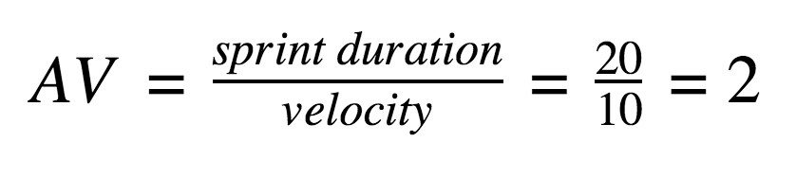

For Sprint-1 the Average Velocity (AV) is: AV = Sprint Duration / velocity = 8 / 6 = 1.3V

For Sprint-2 the Average Velocity (AV) is: AV = Sprint Duration / velocity = 14 / 6 = 2.3V

For Sprint-3 the Average Velocity (AV) is: AV = Sprint Duration / velocity = 16 / 6 = 2.6V

For Sprint-4 the Average Velocity (AV) is: AV = Sprint Duration / velocity = 12/ 6 = 2.0V

TOTAL TEAM AVERAGE VELOCITY = 2.08

**Burndown Chart:**

A burn down chart is a graphical representation of work left to do versus time. It is often used in agile [software development](https://www.visual-paradigm.com/scrum/what-is-agile-software-development/) methodologies such as [Scrum.](https://www.visual-paradigm.com/scrum/scrum-in-3-minutes/) However, burn down charts can be applied to any project containing measurable progress over time.

